**Database Lab Task – 01**

**1. SELECT * FROM dept;**

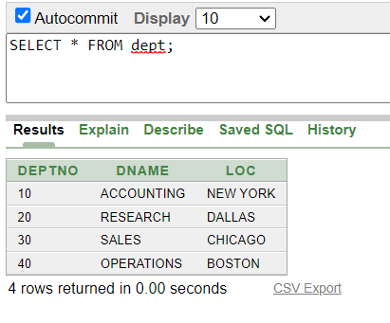

**2.** **SELECT deptno, loc FROM dept;**

**3. SELECT ename, sal, sal+300 FROM emp;**

**4. SELECT ename, sal, 12*sal+100 FROM emp;**

**5. SELECT ename, sal, 12*(sal+100) FROM emp;**

**6. SELECT ename, job, comm FROM emp;**

**7. select ename, 12*sal+comm from emp WHERE ename='KING';**

**8. SELECT ename AS name, sal salary FROM emp;**

**9. SELECT ename "Name",sal*12 "Annual Salary" FROM emp;**

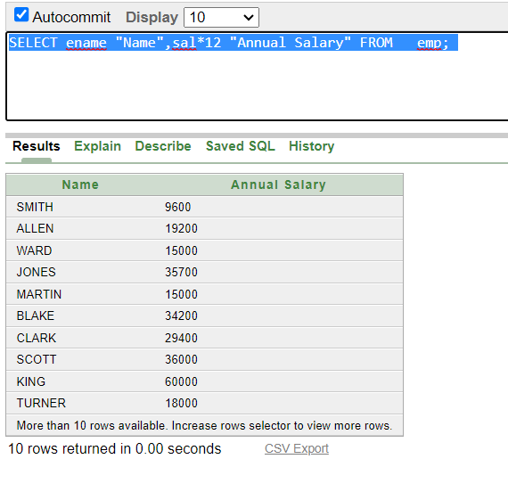

**10. SELECT ename||job AS "Employees" FROM emp;**

**11. SELECT ename ||' '||'is a'||' '||job AS "Employee Details" FROM emp;**

**12. SELECT deptno FROM emp;**

**13. SELECT DISTINCT deptno FROM emp;**

